MAXDat Staging ETL Architecture

July 2, 2012
- Table of Contents
1. Table of Contents 2
2. Table of Figures 2
3. Introduction 2
4. Requirments 2
5. System Architecture 3
5.1. ETL Process Overview 3
5.2. Change Data Capture 4
5.3. Transformation 5
5.4. Jobs 5
6. Kettle Architecture Error! Bookmark not defined.

- Table of Figures

Figure 1 - MAXDat Staging ETL Process Error! Bookmark not defined.
Figure 2 - Change Data Capture Flow 4
Figure 3 – Jobs Process 7
Figure 4 – Pentaho Architecture Error! Bookmark not defined.
- Introduction
This document describes the architecture of the MAXDat ETL system from the OLTP product database to the Staging tables. This is not a description of the BPM portion of the MAXDat system.

The ETL tool that will be used for this element of MAXDat is Pentaho’s Kettle. Kettle is an open source tool specifically designed for ETL applications. Kettle provides a framework for the ETL needed on MAXDat. However, that framework will also constrain the design and may introduce some performance issues. So, designing the system to be as efficient as possible will be one of the main focuses of the system.
- RequirEments
There are five requirements. The first requirement is that the data delivered to the BPM Event tables from the Staging tables is carried out in near-term time -- every 15 to 30 minutes. This requirement implies that all processes of extraction from the OLTP system(s) into all of the Staging tables should be completed within this time frame noted above.

The second requirement is that the transformation portion of the ETL be rule-based in order to allow the changes to be made quickly and by an analyst resource.

The third requirement is that the ETL layer be database agnostic or not tied to any vendor’s technology, such as Oracle, Sybase, or Microsoft. This precludes use ofvendor-specific tools, such as, PL/SQL for the ETL code.

The fourth requirement is that the MAXDat Staging ETL will be transactionally coupled with the BPM Event system. Currently this transaction coupling is accomplished with Oracle Triggers. Transactionally coupling will be evaluated in terms of its performance impact. If the performance requirement is impacted to an unacceptable degree, then de-coupling mechanisms will be explored. Alternatives include a pull from BPM Event system either on demand or based on notification from the Staging ETL upon completion of its ETL job.

Finally, the fifth requirement is the system needs to be able to process data from non-database derived data sources, such as .CSV files, logs, etc.. Some of MAXIMUS’ telephony systems only produce data in the form of .CSV or .HTML.
- System Architecture
An overview of the MAXDat Staging architecture is depicted in Figure 1 below illustrating the flow of data thru the ETL process. The following sections will describe the Kettle specific architecture (refer to Figures/Diagrams?)

See Visio documents:
Architecture-ILEB-MAXDAT
NYEC_Architecture_MAXDAT

  - ETL Process Overview

The ETL process starts with the appropriate collection of data from the various systems of record, such as the ATS OLTP, Telephony ACD, or Imaging systems. These data maybe supplied by network connections, such as SQL*NET, ODBC, or Web, or they may be supplied in the form of files, such as .CSV files, or IVR vendor reports.

There are three general types of data collected from the various systems of record. The first are the transaction data needed to monitor the business processes. These data change frequently and are the relevant changed data.

The second sets of data collected are slowly changing data or SCD. These data are needed for characterizing the transaction data. For instance, the business process needs to know who completed a task. The list of Staff members who may complete a task doesn’t change often and therefore is slowly changing. The system only needs to collect this type of data infrequently or when it changes.

Lastly, there are ancillary data sets. Ancillary data are data needed by the transaction data during the ETL processing, but may not be needed later by subsequent executions of the ETL.

An example of this would be address data needed for the processing of application specific ETL. The address table contains all addresses known to the OLTP system. The ETL processing of applications doesn’t need all address data, just the ones associated with the applications involved in a particular instance of the ETL.

Ancillary data will be gathered in the initialization phase of the ETL process along with the SCD data. Again, the data set needed will be limited to the data needed by the transactional data.

Data needed for the transaction type of data is collected by Kettle. Data for each business process will have a separate data collection process. For instance, Application Processing will have a data collection separate from Process Missing Information. Initially each data collection is run through a Change Data Capture process. The process determines which records are new, have been updated, or “Cancelled”. The collection process is designed to capture the minimum set of records needed so that down stream transformation and loading steps can finish in the required processing time.

  - Change Data Capture
Change data capture identifies records obtained from the OLTP database that are either new or have been changed. Because new records are processed differently than updated records in the Stage ETL, there needs to be this differentiation.

New data records from the OLTP database will not exist in the Stage table. For example, a Stage table contains data from the STEP_INSTANCE and STEP_INSTANCE_HISTORY records from the OLTP db. If the STEP_INSTANCE_ID, which identifies the task that is being worked, doesn’t exist in the Stage table then it is a new record. A new record in the Stage table is marked as New (See figure 2).

Changed records from the OLTP db are those records that have an existing record(s) in the Stage table. The records from the OLTP db are added to the Stage table and marked as updated (U).

Both the new and update records will have separate transformations processes. New records will be processed first and then update records will be processed.

Figure 1 - Change Data Capture Flow

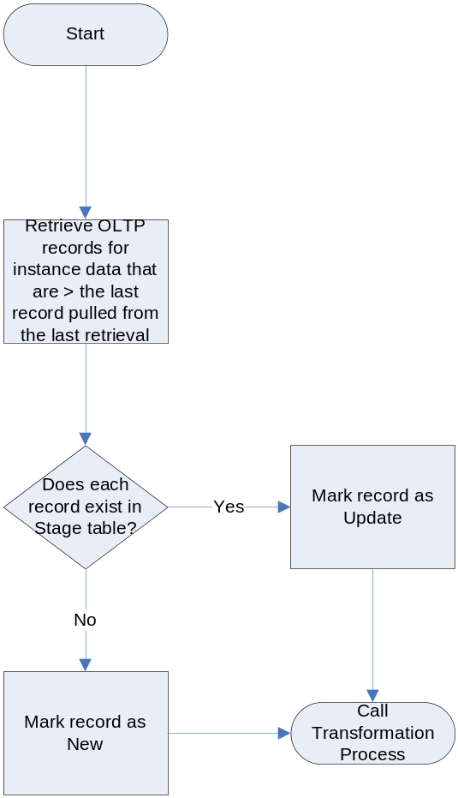

  - Transformation

After the data is collected and the appropriate change data capture category is determined, then the data is processed thru the transformation steps. Each data collection set will have a set of transforms that operate on each of the records collected. The rules for the transforms are maintained in the rules engine component within Kettle. This component is described in the next section.

  - Jobs
The ETL process will be initiated by CRON on a periodic basis. The basis will be determined by each implementation based on reporting requirements. Typically this period will be in the range of 15 to 30 minutes.

At the start of each CRON job it will check that the previous CRON job has completed. All ETL processes will start at the same time and run until each finishes. At the end of each process an event will notify the CRON job of its completion and the CRON job will only finish when all processes have notified.
After the CRON script has determined that the previous CRON job has completed, it will start each workbook and the gathering of the SCD and Ancillary data capture. This is illustrated in the Initialization swim lane in Figure 3. Before the load swim lane can start all of the SCD and Ancillary data capture must be completed to assure that any of the workbook that share these data sets have access to them.

The load step for each work book will then insert new records into the System Stage tables. Any CDC data that needs to be updated will be done at this time. So, for instance, the last new application ID that was inserted will be stored so that the next run of the ETL will know where to start gathering new applications from the OLTP system. The application ID is the primary key of the instance data and therefore is unique and sequential.

Next will be the update section where all updates needed are performed. The updates match one to one with the Update tab in each workbook.

Transformations are done in the next swim lane. Again these transformations match one to one with the Transformations in each of the workbooks. When the transformation for each workbook is completed they will set a system flag that CRON will use to know when all processes have finished in each run.

Finally, the maintenance swim lane takes care of updating CDC control variables in the process control table. Also, any other common tasks needed to finish the ETL process. One such task identified so far is the job that will tell the BPM Event system that the materialized views process may start. Additionally, this could also be a notification that BPM Events system could start fetching new and updated data from the BPM Stage tables, thus de-coupling the transaction from the BPM Event system updates. This would remove the triggers on the BPM Stage tables.

Figure 2 – Jobs Process
